Design Document Unit 4 Assignment 2(Done First)
Requirements Specification
This application will help teach the users how to multiply.
The target audiences for the application will be children aged 6-9.
The application will generate ten random multiplication questions in the form of a quiz.
The question will use the numbers 1 to 10 so the answer must be between 1 and 100.
The application must tell the user if they got the question right or wrong.
At the end of the quiz the programme will show them there score out of ten.
The program will give a supportive message that will help them improve their performances.
The application must have error checking to make sure that only integers between 1 and 100.
Planning
What software development style will we use
I will be using the agile development style as it is iterative and flexible which is good for small applications made by inexpressive developer because it lets you go back to fix mistakes or make additions which you are more like to need for small applications and inexperience developers due to lake of experience.
As the paragraph above implies this application is not very large and the developers making it are not very experienced, so I think this is the best chose of development style.
What IDE will we use
I will be using Microsoft Visual Studio 2022 because it is a reliable IDE that I have experience using as I have been practising with it for a while now.
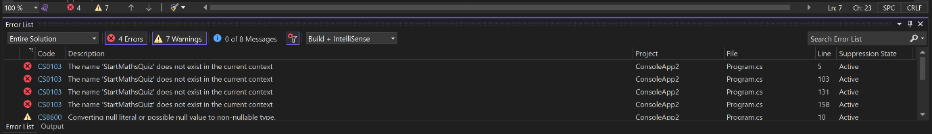
Microsoft Visual Studio 2022 has some very useful features that I know how to use. one of the most useful and simple is its ability to find basic errors, this will save a lot of time if I make a small mistake that I cannot easily identify. this is a feature present in most IDE but I know how to use the version in Microsoft Visual Studio 2022 shown below

Program language
I have chosen to use C# as the programming language I will be using for the application as it is one of the programming languages that I have been practicing and am confident in using. I will make a small list of some of the advantages and drawbacks below.
Advantages
C# is integrated with the .NET Framework this will give you access to a wide variety of libraries and tools this will make the use of pre-built modules much easier.
C# is a object-oriented program meaning it has features like encapsulation, inheritance and polymorphism well this is not unique to C# it is still very useful and an important part of C# programming

C# will automatically deallocate unused objects which will help to lower the risk of memory leaks and assets in memory management in general.
Drawbacks
C# was not designed with mobile phones in mind, well there are still ways for it to work on your phone and develop for phones, its limited and not as good as other programming languages that are made with phones in mind.
C# is slightly resource intensive this should not be a problem considering the size of the program, but C# will still use more resources than other software development languages.
C# is windows centric it is strongly associated with windows and only has limited support for over operating systems this is not too big a problem however as windows is one of the biggest operating systems.
Jobs to be done
I will need to plane the software by Making a flowchart, pseudocode and a wireframe as well as this design document.
I will need to develop the programme I will be using the agile development style, and my IDE will be Microsoft Visual Studio 2022
I will do a pear review and look for things I can improve and give reasons for the ideas I disagree with.
I will need to test the application I will first plan the tests before doing them and put the results in a log.
I will do what I can to optimize the programme.
I will evaluate the programme and development so that I can find thing to improve for the future.
Gantt Time Chart
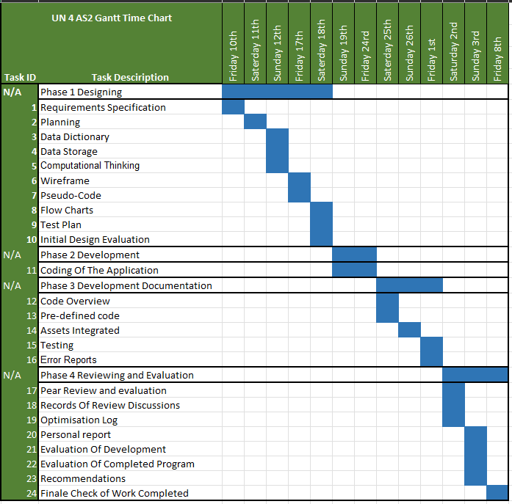

This is the Gantt time chart I have completed it shows how I plan to spend my time. this is important so that I can pace myself and the work. I will need to do to avoid getting into a situation where I have to do the bulk of the work in one night.
I will only be available to work on Friday, Saturday or Sunday as I have over things I must do for the rest of the week. I will have to try and keep to this schedule so that the work will be completed on time but if I cannot complete the work schedule for the day, I will try to get it done on the next as well as the other work, but this might cause some problems if it keeps happening.

Data Dictionary
Name | Data Type | Required | Description | Value
Username | String | Yes | Users name inputted at the start | Dependent on input
FinaleScore | Integer | Yes | Integers whenever the user gets the answer right then displays it at the end. | 1-10
num1 | Integer | Yes | First generate number when generating a number | 1-10
num2 | Integer | Yes | second generate number when generating a number | 1-10
tryAgain | String | Yes | The users input at the end of the program. | 1
answer | Integer | Yes | User input for answering the question | 1-100
Data Storage
There is no non-volatile data being stored by the application as it is not necessary for the application. The only data being stored by the system is volatile date like the name verbal being stored at the beginning of the programme which will be erased at the end of the programme or if the pc losses power.
Computational Thinking
Why we will use computational thinking
Component thinking is a thinking process used to break down and understand problems. It is commonly used for software development as it is a very good way to help understand and solve problems by thinking about them like a computer would.
We will be using computational thinking as it is a useful tool for understanding what we have to do and planning the program we will be making. To help us understand, I will be going over the steps of computational thinking to help better explain what is done in computational thinking.
Step 1 Decomposition
Decomposition is the first step of computational thinking. It involves taking a large problem and breaking it down into manageable parts. This is useful as it is easier to deal with many small tasks than one massive one. Decomposition will also help to reduce the complexity of tasks as when broken down that should only involve doing one or two things compared to doing it all at one’s which would be incredibly complex and not practical.
We will use decomposition to help make the software requirements and break down the brief provided to us into multiple smaller tasks that we will complete as we develop the application. We will make the software requirements using decomposition by going over the information provided and finding all the individual tasks that the program will need when it is completed and putting it in a list.

Step 2 Pattern Recognition

Pattern recognition is the second step of computational thinking. When you are doing pattern recognition you need to identify connections and differences between the steps you made when you have done the first step decomposition. This is important so that you know how the steps you have made will go together to form the finale program.

We will use pattern recognising when we plan how to make the application and develop it so that the plan, we make will make sense in an order that is easy to follow and understand by others and yourself, so that you properly understand what you need to do.

Step 3 Abstraction
Abstraction is the third step of computational thinking. It is the process of finding the most important information from the decomposed steps and defining or generalizing what must be done to solve the problem and make the program.
This will help us in general and practically in the planning of the application. We will need to do this at essentially every level of development. to put it in the broadest sense, abstraction is just the processes of thinking about and understanding the problems at hand.

Step 4 Algorithmic Thinking
Algorithmic thinking is the fourth and final step of algorithmic thinking. Pattern recognition refers to the defining of a step-by-step process for the task that you need to complete. This ties into all the previous steps as you will need to use them to decide and plan on the steps for algorithmic thinking. After this is complete you should have a well thought out step-by-step plan for solving the problem at hand.
This will be a crucial part of the planning and development of the application. This will help us to organize the information gathered in the previous steps into a usable step by step guide for solving the task at hand and make sure that the end result is easily understood and well made.
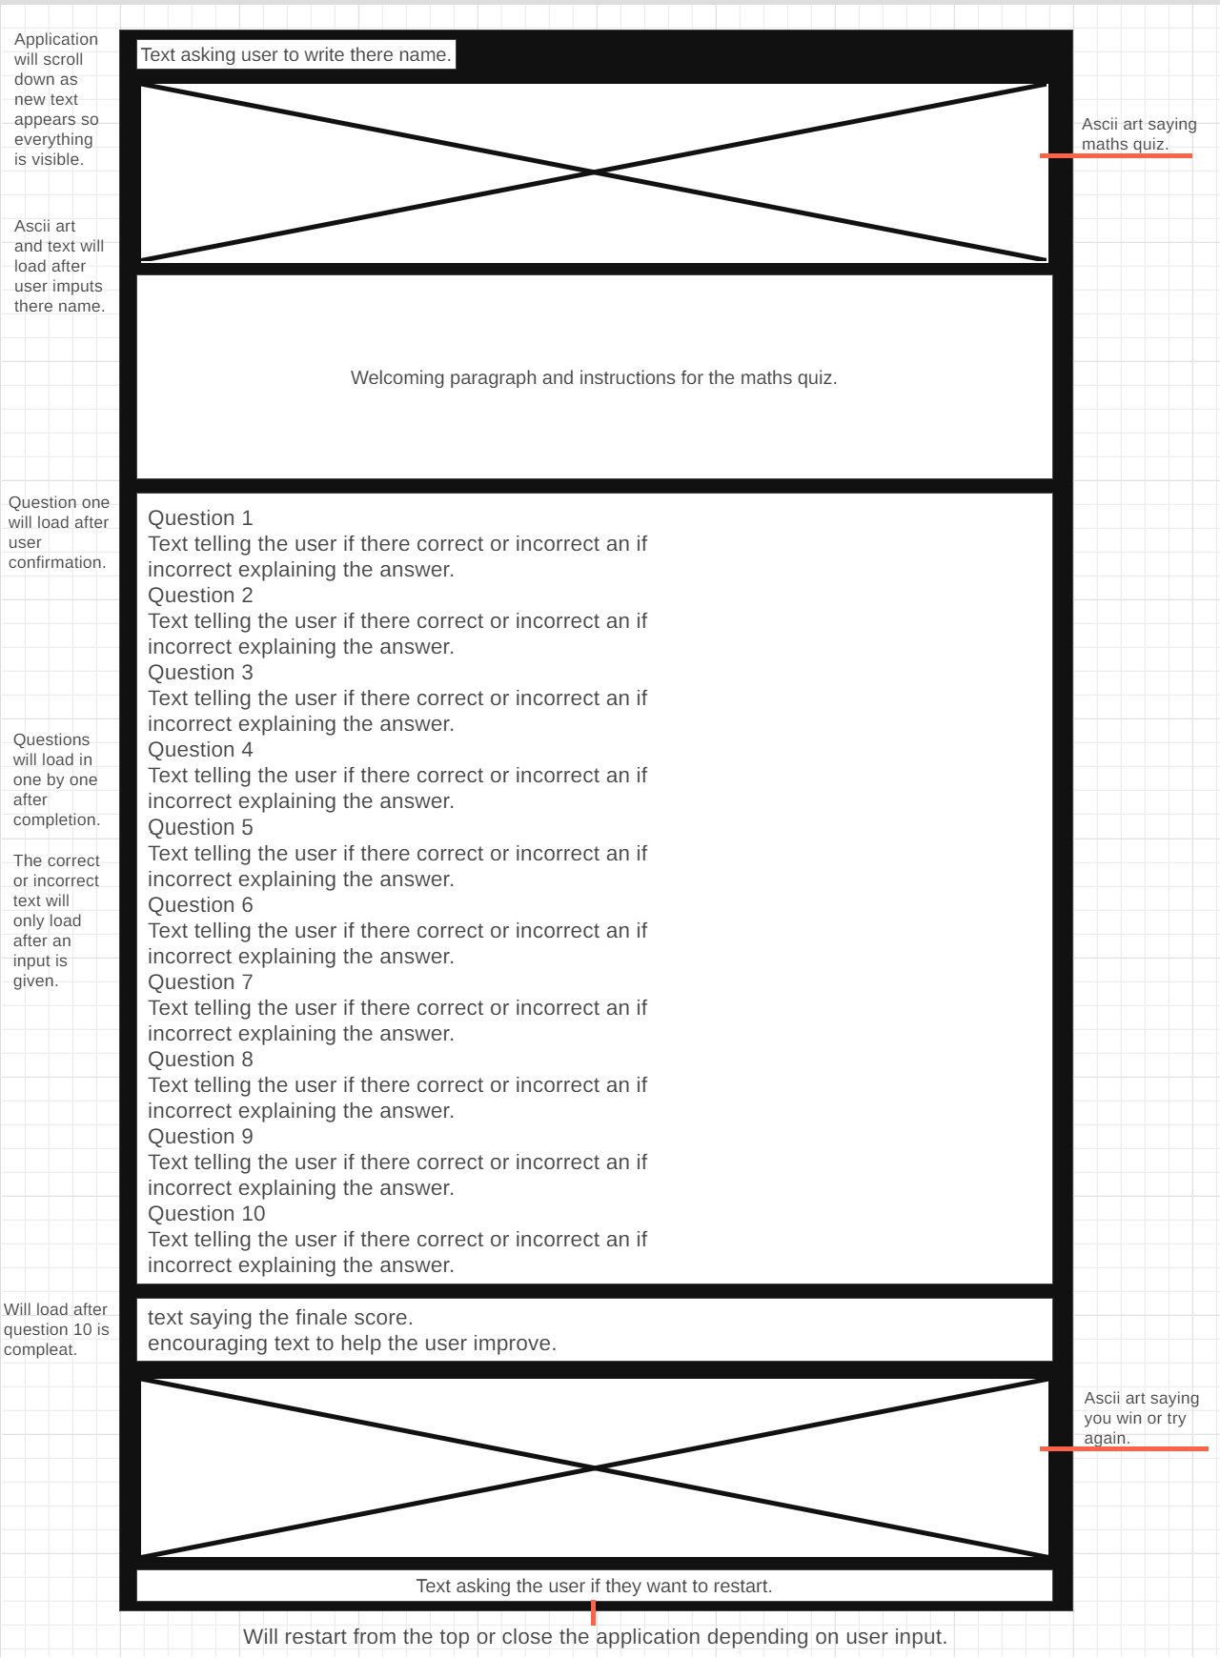
Wireframe
This is the wireframe I have made for the application I plan to develop. It shows where I plane to places text and ascii art, what the ascii art will say, and when things will load in it shows exactly how I plan on the application to look.
This is important so that I know what I am trying to make and what will need to be displayed when I develop the application i don’t have to go back to add things that I forgot are needed.

Pseudo-Code
Start

Step 1 (introduction)
output string “what is your name”;
input = Name;
output string "introduction/ASCII art”;

Step 2 (setting score)
FinaleScore = 0;
random = random();

Step 3 (generating question)
for (Question Number = 0; Question Number < 10; Question Number++)
{
num 1 = random number;
num 2 = random number;

Step 4 (display question)
output string “Question {Question Number} what is {Num 1} x {Num 2}?”;
input = User Answer;

Step 5 (error checking)
while (if input incorrect format)
{
output string “Invalid input. Please enter a whole number.”;
output string “Question {Question Number} what is {Num 1} x {Num 2}?”;
}

Step 6 (checking answer)
if (Answer = Num 1 x Num 2)
{
output string “This is the right answer!”;
FinaleScore++
}
else
{
output string “You got the answer wrong. the right answer is {Num 1} x {Num 2}.”;
}
}

Step 7 (display score)
if (FinaleScore < 4)
{
output string “good job, {Name}! you got {FinaleScore }/10”; (Yellow)
}
else
{
output string “good job, {Name}! you got {FinaleScore }/10”; (Green)
}

Step 8A (encouraging message and ASCII art, low score.)
if (FinaleScore < 2)
{
output string “you need more practise keep trying!”;
output string “try again ASCII art”;
output string "do you want to try again (Y/N)”;
input Y or N;
if (Input = “y”)
{
restart;
}
else if (input = “n”)
{
close program;
}

Step 8B (encouraging message and ASCII art, middle score.)
if (FinaleScore <= 3)
{
output string “you scored low but practise makes perfect, try again!”;
output string “try again ASCII art”;
output string "do you want to try again (Y/N)”;
input Y or N;
if (Input = “y”)
{
restart;
}
else if (input = “n”)
{
close program;
}

Step 8C (encouraging message and ASCII art, high score.)
if (FinaleScore < 6)
{
output string “you scored well grate job keep practising to keep improving!”;
output string “you win ASCII art”;
output string "do you want to try again (Y/N)”;
input Y or N;
if (Input = “y”)
{
restart;
}
else if (input = “n”)
{
close program;
}
}
}
Stop
This is the pseudocode I have made for the application I plan to make. It shows how the code what syntax I might use for the programme when I make the application and what it will need to do. It also shows how I think the code will roughly look and the tasks it will have to perform.
This is important so that I know what the code will be doing and have an idea of how I will make the programme once I finish planning and dishing. It is also important so that I can have any idea of how this software will work before I start to make it.
Flowcharts
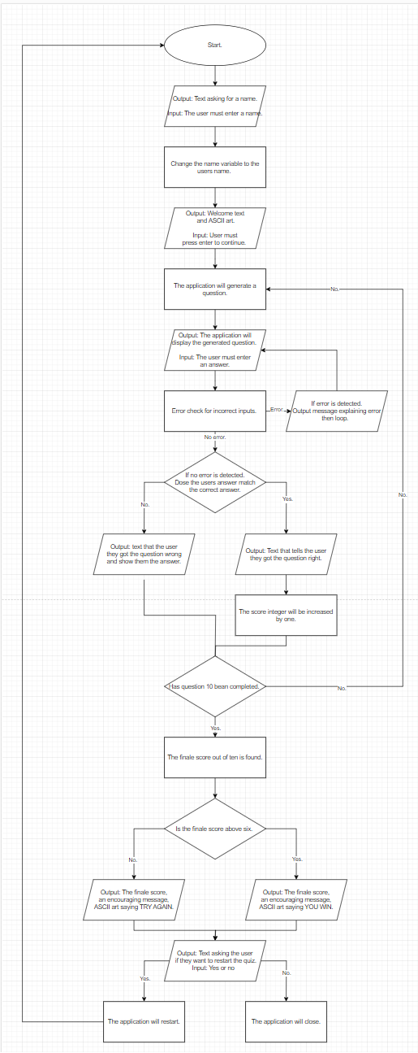
This is the Flowchart I have made for the application I plan to make. It shows how the code will flow when I make the application and what it will need to do. The flowchart also demonstrates the algorithms I will use and where the code will need to branch off.
This is important so that I know what the code will be doing, how it will flow, where are it will branch off and help me have an idea of how I will make the programme once I finish planning and start developing the program.
Test Plan
I will need to test the system for functionality and performance, to do this I will be using black boxes testing. Black boxes testing is the process of testing a software without knowledge of what’s happening inside the code. well, I will be making the code and have some knowledge of how it works I will make the test plan in a way that acts as though I have no knowledge of the inner workings of the systems. I will list the test I plan to do bellow.

Test 1:
I need to check that the application will open and close as expected.
To do this I will open and close the application 3 times to ensure that it opens and closes properly.
The expected outcome will be that the application opens and closes with an appropriate speed.
Test 2:
I need to check that the application properly accepted and uses the name the user inputs at the start of the application.
To do this I will input a name at the beginning of the application and check it appears properly through the application I will do this for each outcome that is possible.
The expected outcome will be that thee inputted name will appear at the appropriate points in the program.
Test 3:
I need to check that the introduction text and ASCII art loads in correctly at an appropriate speed.
To do this I will load the text multiple times to check that the appropriate text loads and that it does so at an appropriate speed.
The expected outcome will be for the text to load in correctly and within an appropriate time.
Test 4:
I need to check that a question is properly output at the start of the program and after a question Is completed (so long as ten questions have not been complete)
To do this I will do this be checking three times that a question loads at the start of the program and when a question is complete.
The expected outcome will be for the questions to load at the start of the program and after a question is completed.
Test 5:
I need to check that the application will accurately detect correct and incorrect answers.
To do this I will complete the quiz with all purposely wrong answers to make sure none are incorrectly marked correct and then do the quiz with answers I have checked are correct to ensure that they are marked correctly.
The expected outcome will be for wright and wrong answers to be marked correctly.
Test 6:
I need to check that the finale score is accurate to the amount of correct and incorrect answers.
To do this I will complete the quiz three times and check that the finale score is accurate.
The expected outcome will be that the final score is accurate to the amount of correct and incorrect answers.
Test 7:
I need to check that when you get a score of greater than or equal to three but no higher than five you get the middle score ASCII art and encouraging message.
To do this I will complete the quiz three times and get a score of 3,4,5 and check that the correct art and text is displayed.
The expected outcome the appropriate ASCII art and encouraging message will display if the score is correct.
Test 8:
I need to check that when you get a score of zero up to two you get the low score ASCII art and encouraging message.
To do this I will complete the quiz three times and get a score of 0,1,2 and check that the correct art and text is displayed.
The expected outcome the appropriate ASCII art and encouraging message will display if the score is correct.
Test 9:
I need to check that when you get a score of greater than or equal to six you get the high score ASCII art and encouraging message.
To do this I will complete the quiz five times and get a score of 6,7,8,9,10 and check that the correct art and text is displayed.
The expected outcome the appropriate ASCII art and encouraging message will display if the score is correct.
Test 10:
I need to check that the application will proper loop or close at the end of the program depending on the input.
To do this I will complete the program and input the y and n input tree times to see that the application will close or loop correctly depending on input.
The expected outcome will be if I press Y the program will loop and if I press N the program will close.
Initial Design Evaluation
I have gone through the designs and plans I have made here to ensure that they are accurate to what are need in the software specification. I think that the flowchart and pseudocode will help me to understand and develop the program in a clear and easily maintainable way. I think that the choses that I have made for the integrated development environment and program language I plan to use are well thought out and explained in a way others will understand.
I have also had some of my pears analyse the designs here and they have not found any issues with what I have developed and did not need to advise me to add any additional information to the design of the program.
With this stage of development complete I will be moving onto the development of the program.

Development log
Making the programme
Please check the provide code dump file for the full commented code
Code Overview
In this section I will be going over the code I have developed and explaining what it does to give a clear understanding of what it does.
This is important so that others can understand my code and why I have made it in the way I have which will be needs if the program needs to be changed or modified in the future.
Stage 1 Start of Program
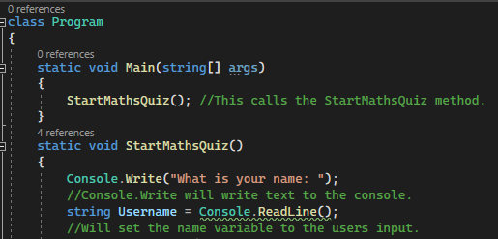
This code is responsible for the start of the program setting where calling StartMathsQuiz And making the static voids. The next stage will start after this without need for input.
Stage 2 Name Input
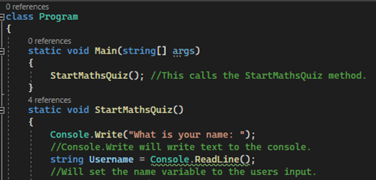
This code will ask the user to input their name and then save the user input as the Username variables value. The next stage will start after the input is given.
Stage 3 Introduction Text
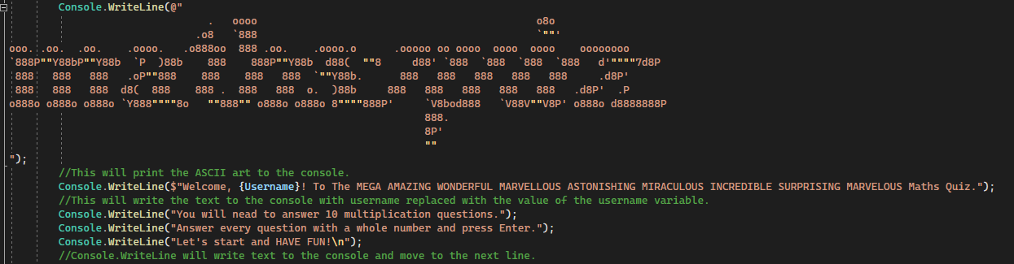
This will code print the introduction text with the username variable set-in stage 2. The next stage will start after this without need for input.

Stage 4 Setting FinalScore and random class
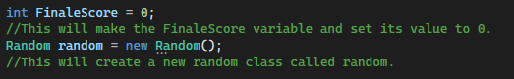
This code will set the FinaleScore variable as an integer with the value of 0 and then create a new random class for later use. The next stage will start after this without need for input.
Stage 5 Question Generation
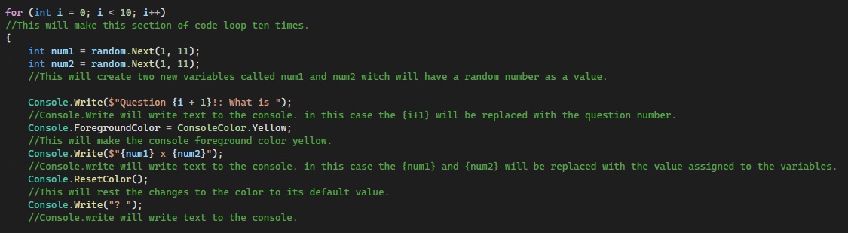
This code will generate and display a question by generating two random numbers as the value of num1 and num2 and then displaying num1 and num2 to the user using Console.Write. this will loop 10 times because of the for statement. The next stage will start after the user inputs their answer.
Stage 6 Error Checking for Answer Input
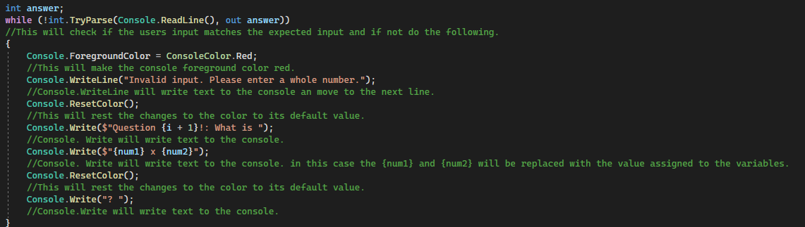
This code will check that the user has inputted a valid number if they have not, an error message will be displayed, and the question repeated. If the user enters a valid number nothing will appear to happen for them. The next stage will start after this without need for input, unless there is an error then they will need to reinput an answer.

Stage 7 Answer Checking and Score Keeping
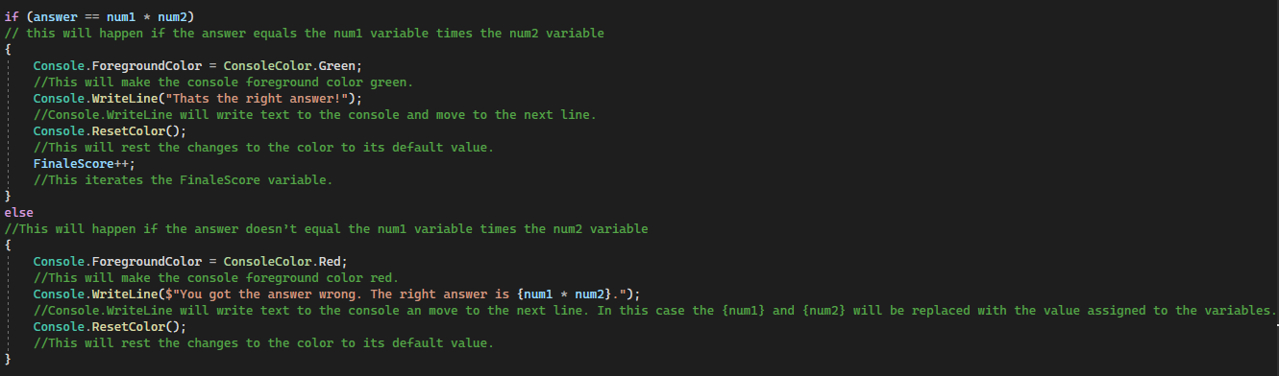
This code will be for checking if the user got the answer right or wrong. if their answer is equal to num1 times num2 then the code will display text saying you got the answer right and iterate the FinaleScore variable. If the user got the answer wrong, then a message will be displayed telling them the proper answer and the score will not iterate. The next stage will start after this without need for input so long as the for statement at stage has iterated ten times.
Stage 8 part 1 Results Initial Text
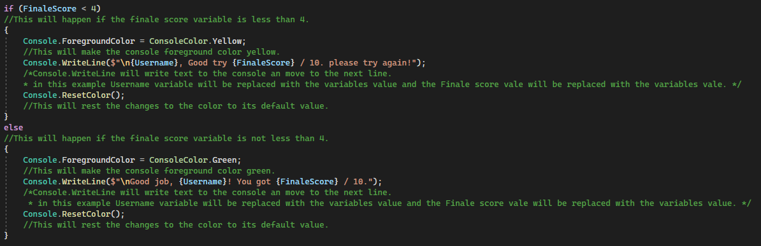
This is the code that will display the first line of the results screen depending on the FinaleScore variable. if the user scored blow 4 then the first statement will be printed but if they got higher than 4 the second statement will print. The next stage will start after this without need for input.

Stage 8 part 2 Answer Less Than Two
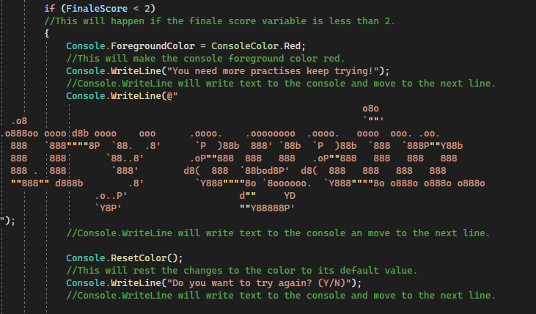
This text and ASCII art will be displayed if the FinaleScore variable is less than two. Stage 9 will start after this without need for input.
Stage 8 part 2 Answer Less Than Five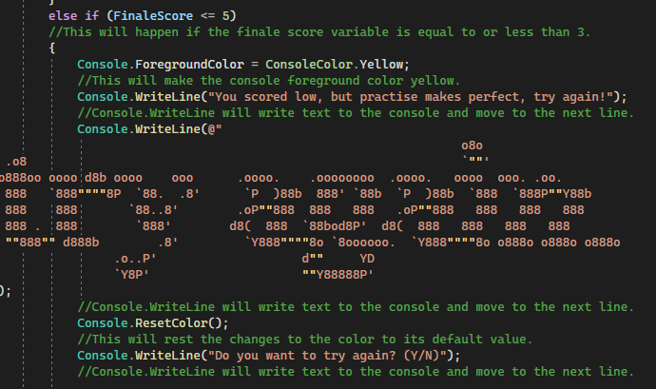
This text and ASCII art will be displayed if the FinaleScore variable is less than or equal to 5. Stage 9 will start after this without need for input.

Stage 8 part 2 Answer Greater Than or Equal to Six
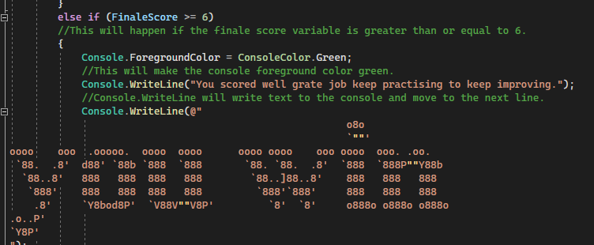
This text and ASCII art will be displayed if the FinaleScore variable is greater than or equal to six. Stage 9 will start after this without need for input.
Stage 9 Close or Loop the Program
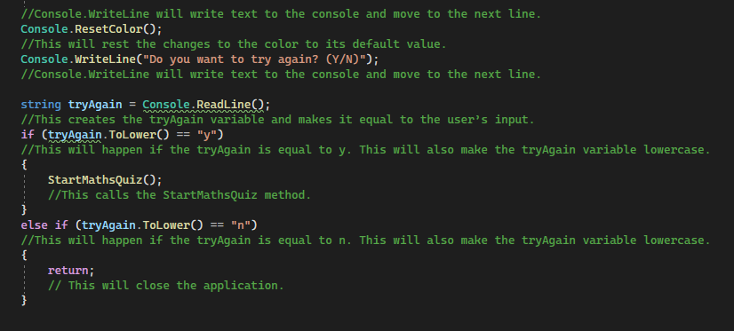
This code will display text asking the user if they want to try again and if the user input a y, then the StartMathsQuiz method will be called again. If they input a n, then the program will close.

Pre-defined code
Console class methods used
Console.Write
Use
Console.Write is used to write on a singe line and will be used when I need to write a small sentence that will not need to be on multiple lines.
Example
Console.Write("What is your name: ");

Console.WriteLine
Use
Console.WriteLine is used to write on multiple lines and will be used when I need to write a large amount of text that will need to be on multiple lines.
Example
Console.WriteLine($"Welcome, {Username}! To The MEGA AMAZING WONDERFUL MARVELLOUS ASTONISHING MIRACULOUS INCREDIBLE SURPRISING MARVELOUS Maths Quiz.");

Console.Readline
Use Console.Readline is used so that the program can read the users inputs in the console witch is need for the users to be able to respond.
Example
string Username = Console.ReadLine();

Console.ForgroundColor
Use
Console.ForgroundColor charges the color of the text when the program is running.
Example
Console.ForegroundColor = ConsoleColor.Green;

Console.ResetColor
Use
Console.ForgroundColor resets the color of the text to what it originally was.
Example
Console.ResetColor();

Random class
Random random = new Random();
Use
This can be used to make a new instance of a random number generator.
Example
Random random = new Random();
int num1 = random.Next(1, 11);
int num2 = random.Next(1, 11);

Looping structure
for
Use
Loops through a part of the code till a specified condition is meet.
Example
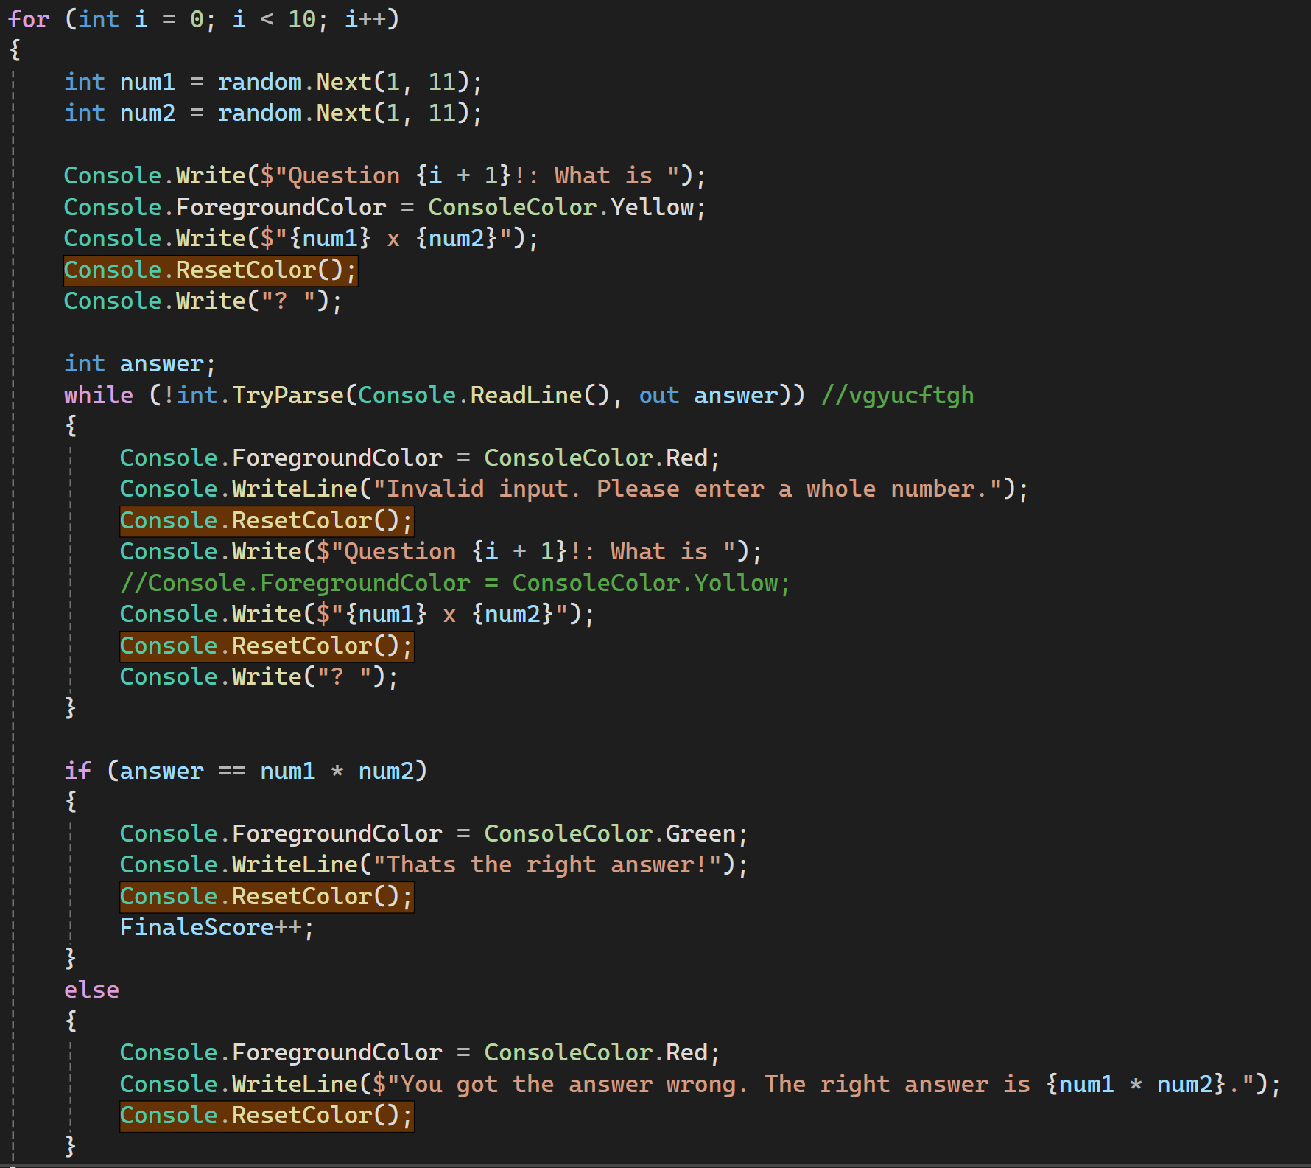
Conditional statement
If/else statement
Use
If/else statements are used to make changes in the program based on the value different variables.
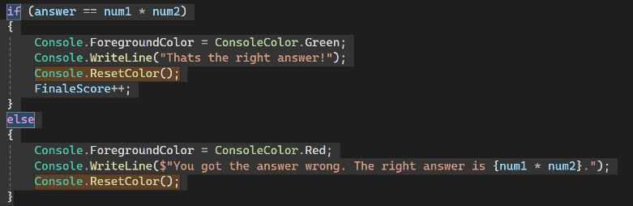
Example

Assets Integrated
I will make a list of any of the assets integrated into the project and their sources. this is important so that I know where I have gotten the assets and what they do. most of the quiz is simple text in the console so there are not many assets present in the application.
Asset 1 maths quiz ASCII art
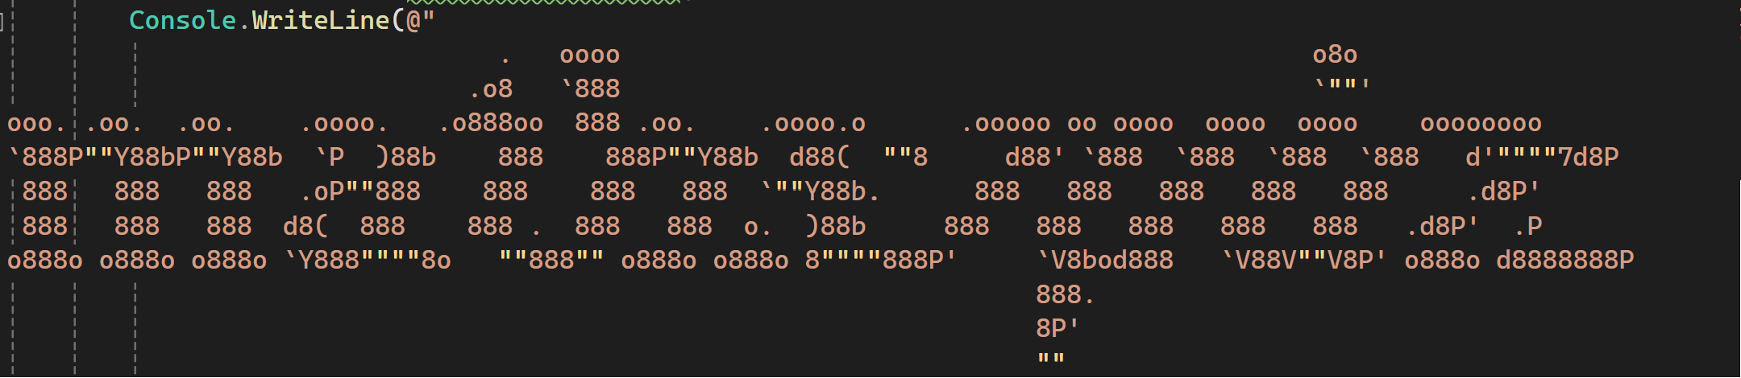
Source
https://patorjk.com/software/taag

Asset 2 try again ASCII art 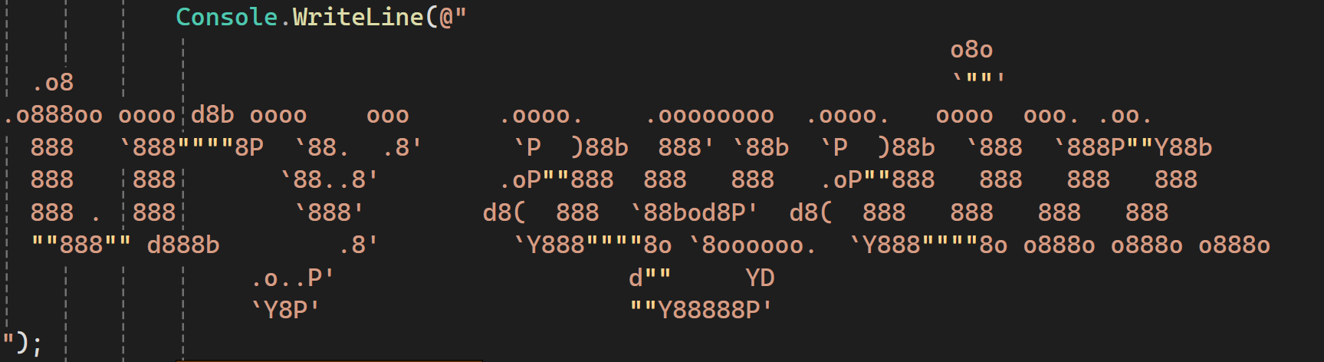
Source
https://patorjk.com/software/taag

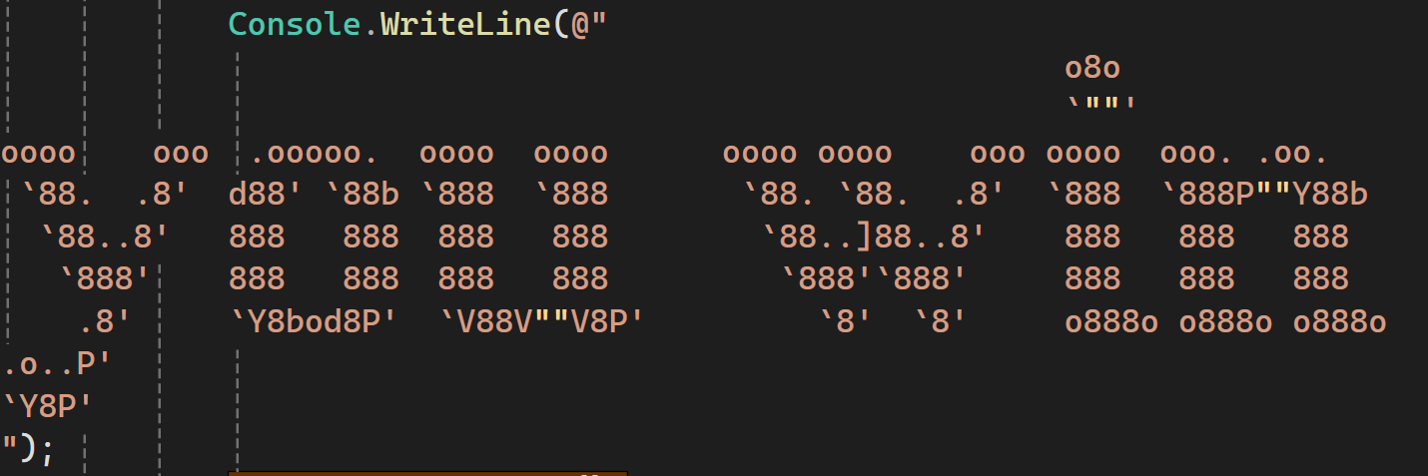
Asset 3 you win ASCII art

Source
https://patorjk.com/software/taag

Testing
in this section I will be going over the testing, fixing and optimization of the application I will be using the testing plan from the end of the design doc for the test log and proceed from there to error checking and optimization.
Test Logs
Test  num | Test | Expected Outcome | Outcome | Fix | Retest
1 | Open and close the application three times. | Application opens and closes with an appropriate speed. | Same as expected. | N/A | N/A
2 | Input a name at the beginning of the application and check it appears properly through the application, I will do this for each outcome that is possible. | The inputted name will appear at the appropriate points in the program. | Same as expected. | N/A | N/A
3 | Load the text three times to check that the appropriate text loads and that it does so at an appropriate speed. | The text will load in correctly and within an appropriate time. | Same as expected. | N/A | N/A
4 | Check three times that a question loads at the start of the program and when a question is complete. | The questions will load at the start of the program and after a question is completed. | Same as expected. | N/A | N/A
5 | Complete the quiz with all wrong answers and then do the quiz with answers I have checked are correct. | Right and wrong answers will be marked correctly. | Same as expected. | N/A | N/A
6 | I will complete the quiz three times and check that the finale score is accurate. | The final score is accurate to the amount of correct and incorrect answers. | Same as expected. | N/A | N/A
7 | Complete the quiz three times and get a score of 3,4,5 and check that the correct art and text is displayed. | The middle score ASCII art and encouraging message will display if the score is correct. | 4 and 5 did not work as I had accidentally put a <=3 instead of a <=5 in the if/else statement | Replaced the 3 with a 5 | Same as expected
8 | Complete the quiz three times and get a score of 0,1,2 and check that the correct art and text is displayed. | The low score ASCII art and encouraging message will display if the score is correct. | Same as expected. | N/A | N/A
9 | Complete the quiz five times and get a score of 6,7,8,9,10 and check that the correct art and text is displayed. | The high score ASCII art and encouraging message will display if the score is correct. | Same as expected. | N/A | N/A
10 | Complete the program and input the y and n input tree times to see that the application will close or loop correctly depending on input. | If I press Y the program will loop and if I press N the program will close. | Same as expected. | N/A | N/A
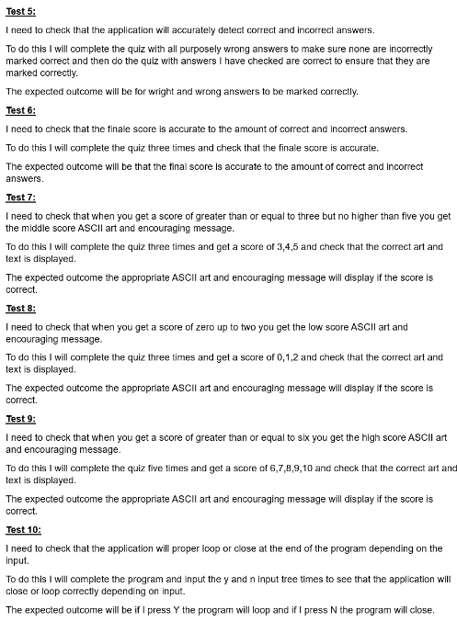
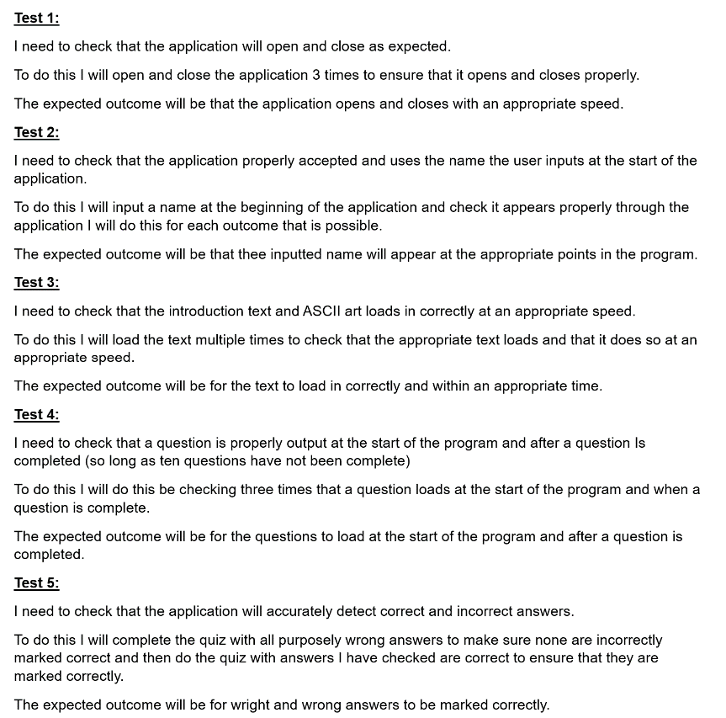
Test from design document (copy)

Error Reports
I missed a [ on line 3 that prevented the code from running properly.
I had misspelled string on line 11 that meant that the program would not properly set the name variable.
(Later renamed to Username)
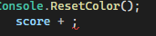
The score iterator on line 85 had Needed a ; to work correctly. (Later renamed to FinaleScore)
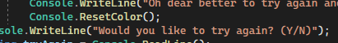
The Console.ResetColor on line 95 was missing a (
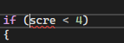
I had misspelled Score on line 100 preventing the if statement from working correctly.
I had misspelled next on line 42 preventing questions from loading properly.
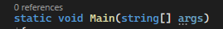
I had forgotten to add a Static on line 3.
Scroll down for pear review.

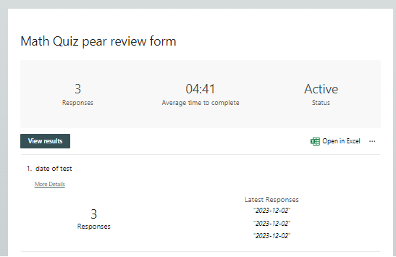
Pear Review
My response
I have done an anonymise pear review to gather feedback on my Maths Quiz. On the left is the response I have got from the form I sent out. I will now be responding to all the feedback and making decisions on what needs to be done.
The feedback form has been completed by 3 people, it took an average of 4:41 minutes and all were completed on dec 2nd 2023 the day I sent it out. there is not anything I can do with this information to improve my maths quiz but is important for to help me know how many people have completed the form.
Question two, how would you rate the math quiz overall.
The average rating of the maths quiz overall was 9.33 this is a very high score and indicates that most people find the math quiz to be quite good overall and have few overall complaints.
Question 3, how would you rate the math quiz suitability for children.
The overall score for the math quiz suitability for children is 8 but two of the responses were sevens which to me would say that well the response was still good but not grate and this is an area I may want to improve.
Question 4, what do you think of how the math quiz preformed.
The overall score for performance was 9.67 this is a very high score and tells me that the users did not encounter any significant bugs or load speed issues.
Question 5, how would you improve or optimize the math quiz.
The three responses all say they don’t know how to improve it or that it was fine. This is dose not help me to add anything to the math quiz, but dose tell me this doesn’t need to be my focus for improvement.
Question 6, how would you improve the math quiz in general.
Response one says they want more color this would be easy to implement, and I think would help keep the attention of children so I will consider it.
Response two say they want me to improve the introduction text but does not specify how. I will think about this, but I don’t really know what to improve so I might not be able to do this.
Response three was asking for more questions but this would go against the software specification, so I won’t be doing it.
Question 7, how would you improve the math quiz for children.
Response one thought it was too wordy for children I will consider this, but I think it is relatively easy to understand so I will likely only change specific words I think are too difficult to understand.
Response two wants more art this is easily implemented, and I will probably do this as it will not have any large drawbacks either.
Response three was asking for more color this was already discussed on the last section so I will likely do it if it has been mentioned twice.
Question 8, any other comment.
There were no usable responses. Which hopefully means they did not have anything to complain about with the math quiz.

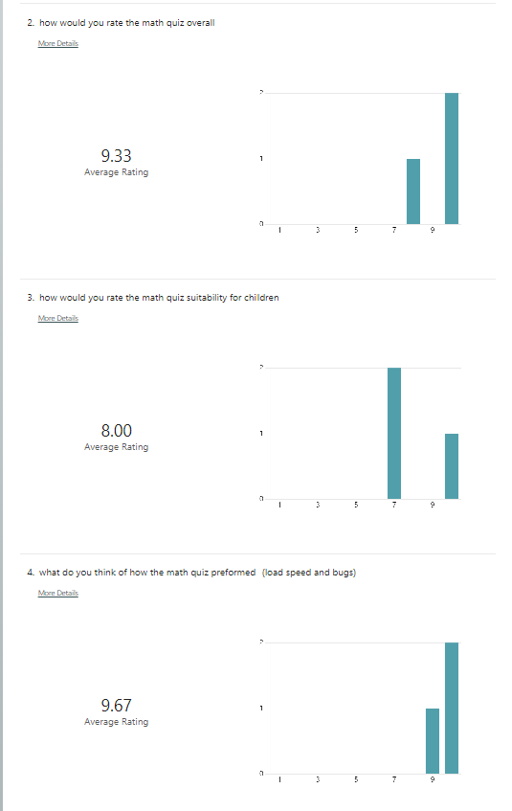

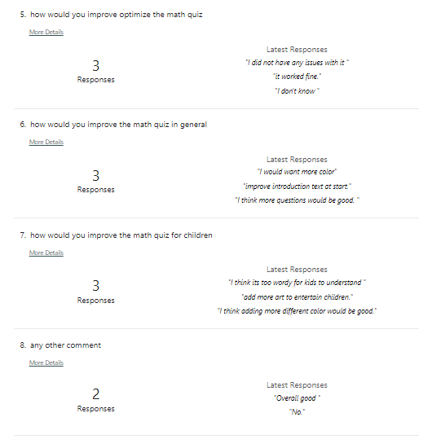

Records Of Review Discussions
Overall, most people seem to like my math quiz which is good is what I was hoping to see, it would also seem that the main section I need to improve is the suitability for children who are the target audience. I will now go over what I plan to change after the pear review.
Change one will be to add more color to the application as this was mentioned twice so it would seem most people would agree with this improvement and It will not be hard to implement as I can just add a few easy lines of code.
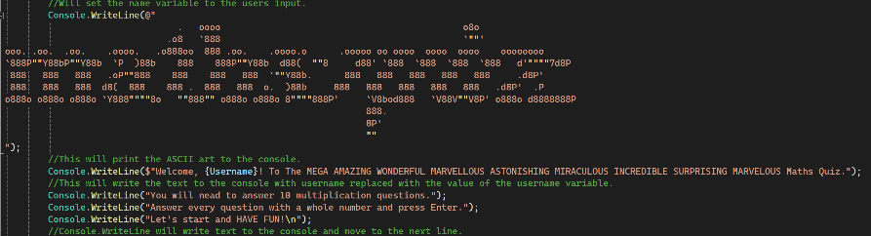
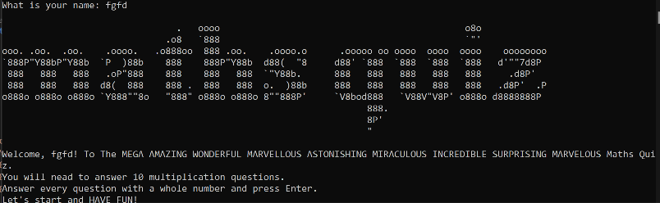
Before change
This is what the program and code look like before I had modified it too add more color.
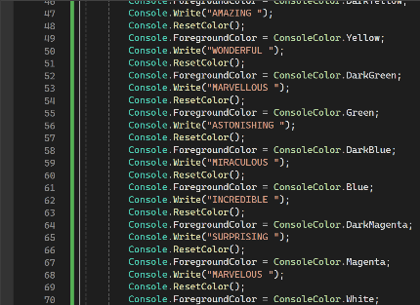
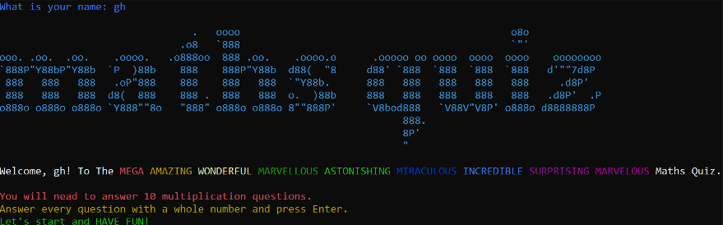
After change

This is an example of some of the color changes I made to the program. I like how this has turned out and I think it will make the application much more interesting for kids.
Change evaluation
I think that this change helps to improve the look of the application as well as making the program more attention grabbing for the user, who will be predominantly children, whom might otherwise not have that much interest in completing the math quiz.
Change two will be to add more ASCII art to help keep the children attention this will be easy to implement and improve the style of the program.
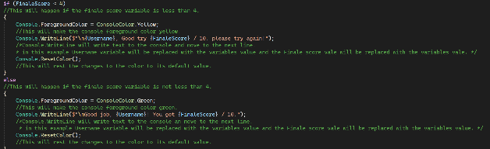
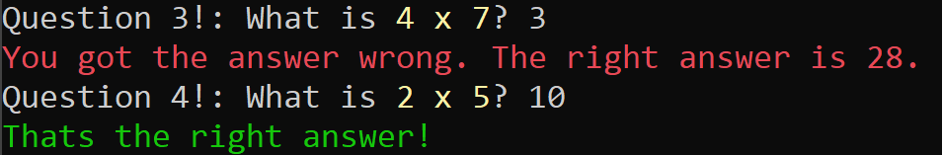
Before change
This is an example of what the program looked like before modifying the software to add more ASCII art.
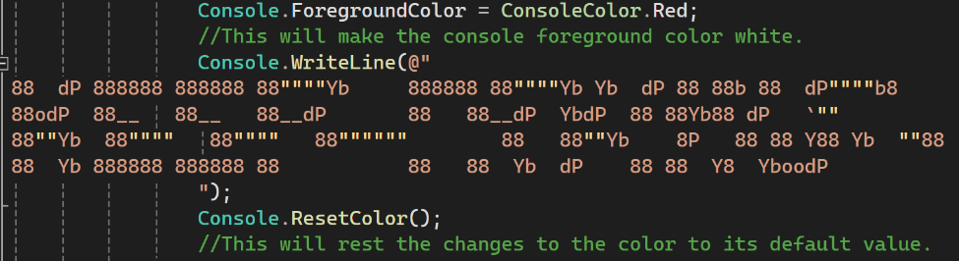
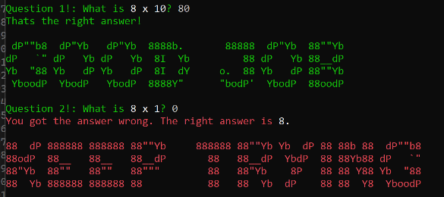
After change
This is an example of how I have added more ASCII art to the maths quiz. I think this will help to encourage children to finish the program and came out well.

Change evaluation
I think this is a good change to the program as it will to encourage the young users to keep going and reach the end of the program by providing them encouragement.
Optimisation Logs
As I am new to programming this optimisation is something I struggle with, but I have made my best attempt to optimise the program through development I will go over some of this now as well as some additions to the program I have done for optimization.
Optimization through development
I have used a for statement to loop the question generation ten times instead of just posting the question ten times which will help to improve maintainability in the program.
I have added some user input validation for the answer section I would have liked to add validation for text inputs but could only figure it out for number inputs.
I have fully commented the code which will help to maintain the code by explain what everything dose so overs can quickly understand what it does.
Finale optimizations for the software
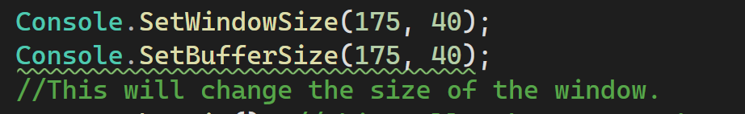
I have added this code so that the program will now have a appropriately sized window when it is running. I did this as it was slightly too small before and some of the lines of text would abruptly go to the next line in the middle of a word.
I have set the program from a debug version too a release version this will help the program run properly and more efficiently. Before the change the application used 10 MB of my processor after it only used 8 MB.
Personal report
In this section I will be going over how I have taken individual responsibility and how I have been managing myself while completing the project. This is important so that I can demonstrate that I am reliable and capable of completing tasks by myself.
Communication and teamwork
I have been communicating with and assisting my pears to help them with their projects and to ask them to help with my project. I have been trying to ensure that my behaver and speech are appropriate, professional, supportive and done with proper etiquette this is important so that I am communicating effectively and that I do not create a hostile work entertainment for my colleges. I will display some of the communications I have had with my colleges here to provide prove that I have bean keeping to proper communication methods.
Example 1
Example 1
In this example I have provide a useful extract from a book that I believe will help them and offered more information if they needed it. I believe was polite and direct when I made this message but some of my grammar and spelling was wrong.
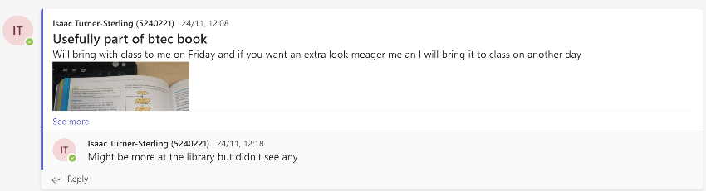

Example 2
In this message I had provided a photo of a whiteboard with some useful information on it. The messages that came with the image was to the point and polite but was not properly written out which might cause confusion if this information is later needed.
Example 2
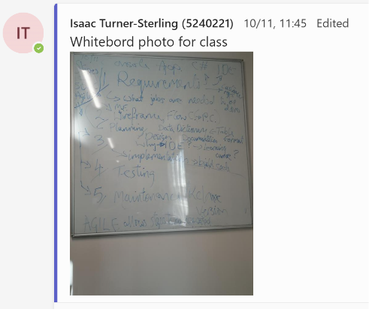

Example 3
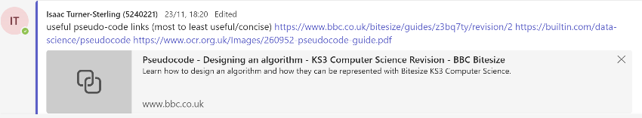
Example 3
I this message I provide a series of useful links on how to do pseudocode. I believe was direct and clear in my message.

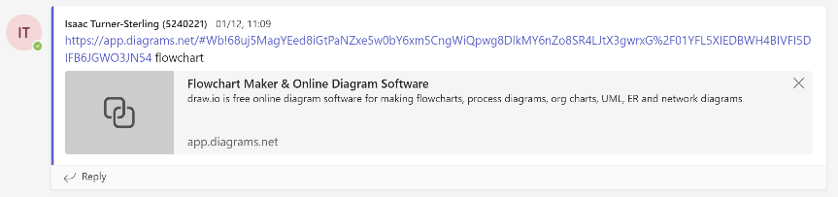
Example 4 and 5
Example 4 and 5
I have grouped these two examples together as they have the same pros and cons. I hade posted these links and information in response to a conversation and did not really include a proper message this could cause confusion if we need to reference this information later. in the future I will ensure that I include a proper explanation.

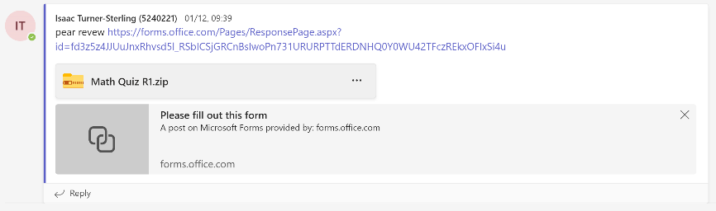

summery
Overall, I think I did a good job being polite, direct and supportive but in the future, I need to unsure that I write in clear full sentences with plenty of information so that my messages can be more easily understood. This is practically important in the event they are needed by somebody who would not have the context of the messages.
how I have managed my responsibilities and time
in this document I have bean going over all the decisions I have made and how I have planed to do things I think that this document here dose a good job of displaying how I have taken induvial responsibility, creativity and managing myself.
I think that a good example my individual responsibility is the commented code I have fully commented the code myself so that I know that others will understand it properly. I did this as I was the one who made the code so its my responsibility to make sure it’s understood.
I think a good example of my creativity is the pseudocode this take a lot of creative thinking and understanding of how the code will work.
I think a good example of how I have been managing myself is the planning section which goes over much of the things I will need to do. It is important so that I know what I would have to do.
I think a good example of how I have managed my time is the Grenet time chart I have made in the design have it shows how I planned to manage my time and I have largely keep to it.
Evaluation Of Development And Completed Program
Evaluation of designs
I have completed the development of the programme and have used the designs and illustrations made in the design phase to make the program I found the plans and illustrations very useful practically the flow chart and pseudocode which helped me to understand how the program should be developed.
The choices I have made in the development stage have created a well working and effective result that meets all the system requirements I will now go over the requirements and show how they have been completed.
This application will help teach the users how to multiply.
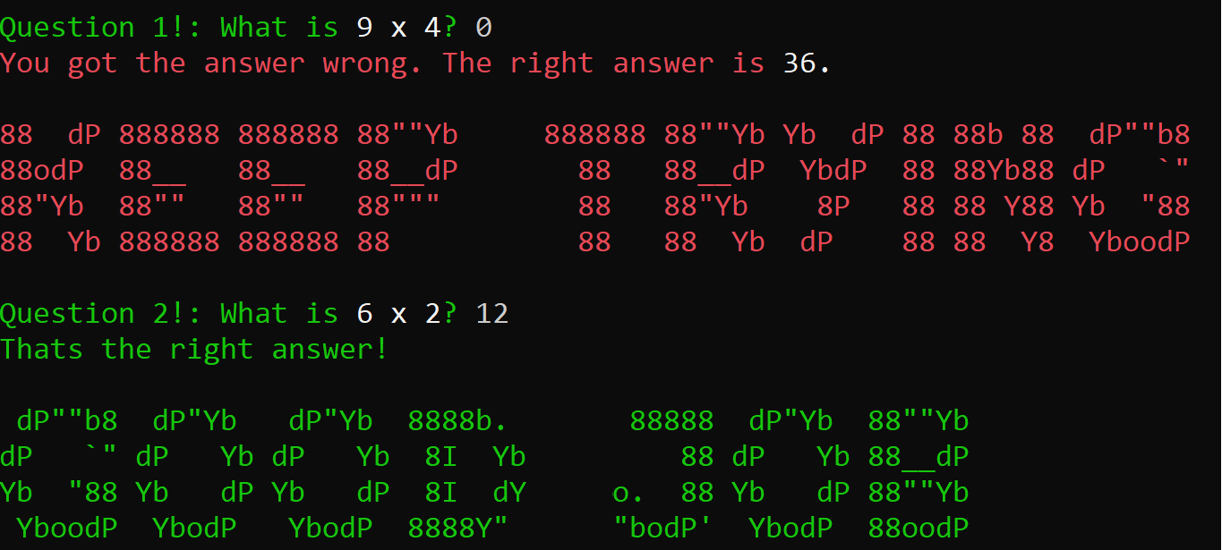
The quiz I have made will help users to learn math by giving them math questions as demonstrated here.

The target audiences for the application will be children aged 6-9.
I have tried to keep this quiz appropriate for kids by making it as entertaining and colourful as possible this is best shown here.
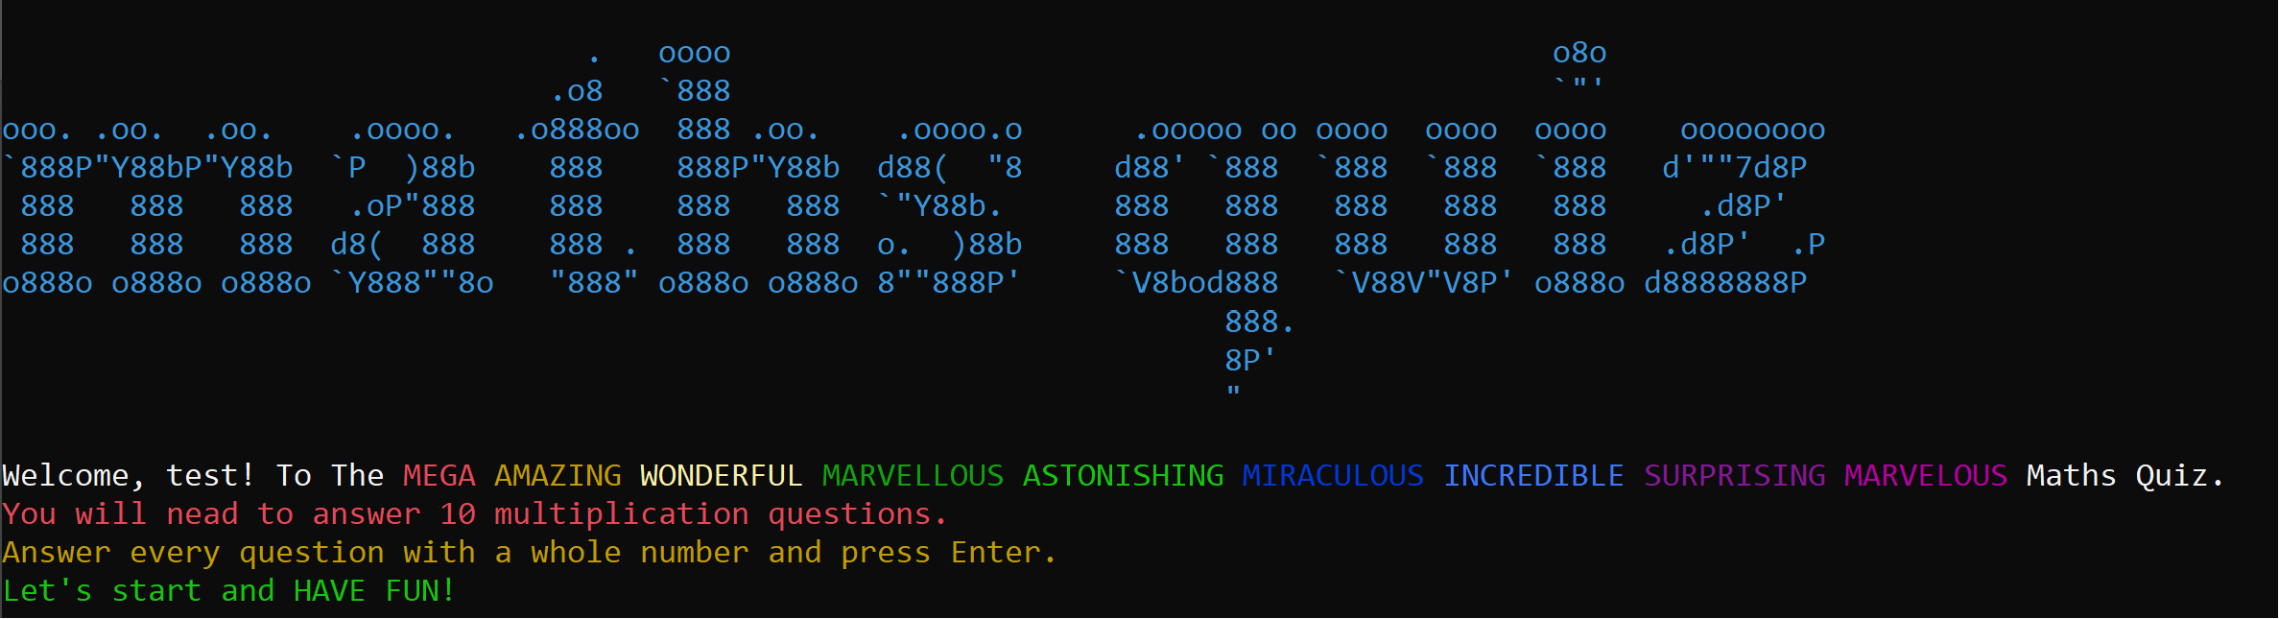
The application will generate ten random multiplication questions in the form of a quiz.
This has been completed and the program dose display ten random multiplication questions as shown here.
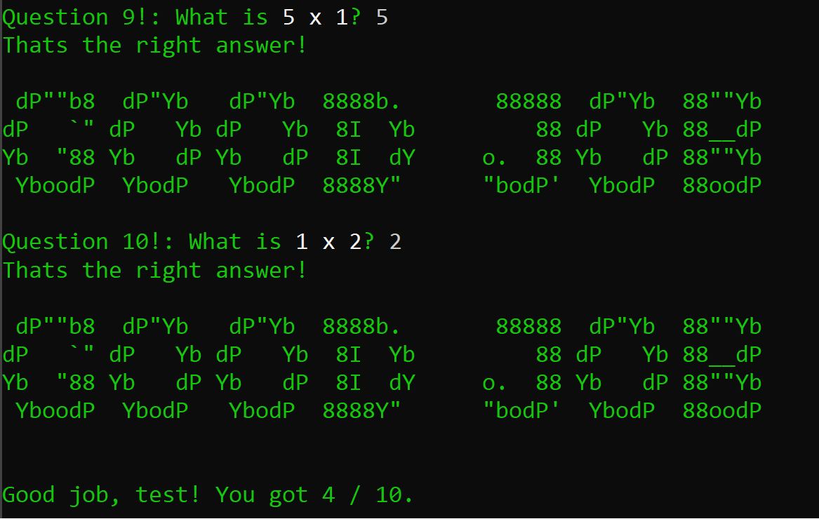
The question will use the numbers 1 to 10 so the answer must be between 1 and 100.
This has been done in the finished program as you can see in the question screenshots above the question generated only use this is because of this code.
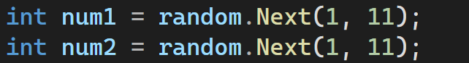

The application must tell the user if they got the question right or wrong.
I have completed this. The program will tell the user if they got the question right or wrong with both text and color.
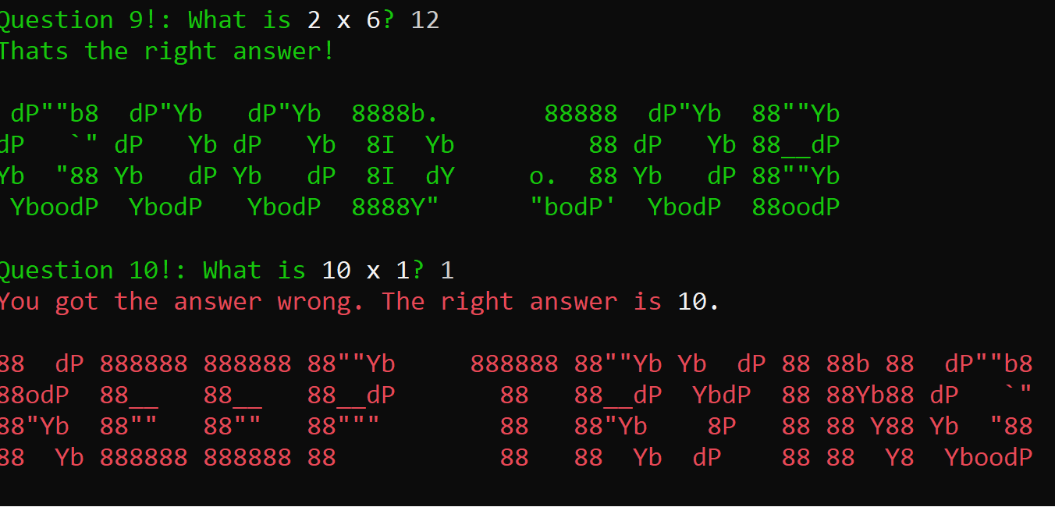
At the end of the quiz the programme will show them there score out of ten.
I have done this as shown in the screenshot there is a section at the end of the quiz that will go over their score.
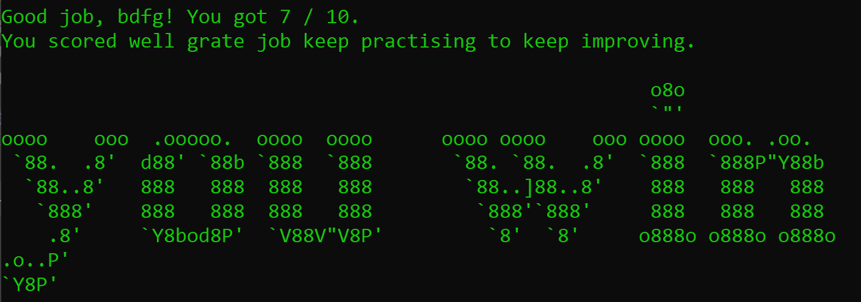
The program will give a supportive message that will help them improve their performances.
This has been done repeatedly thought the program as I will show here. This will help users to know if there right or wrong and too helping them develop if they are wrong.
The application must have error checking to make sure that only integers between 1 and 100.
This has bean done so that only numbers between 1 and 100 can be inputted, I will demonstrate this bellow.
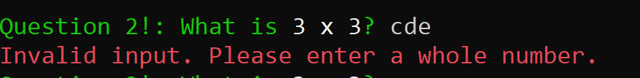
Evaluation of completed program
I think that the finished program works very well for what was wanted by the specifications as I have already shown the program meets the specifications and, in my opinion, works very well as a fun child friendly math quiz. I will now go over some of the details of the application now to demonstrate how I have made the final product fit for purpose.
I have made strong use of color throughout the program which I think will help the user as the target audience will be younger children as they do not usually have good attention spans.
I have started the quiz with some encouraging introduction text and ASCCI art that will help explain the quiz to the user and encourage the user to finish the quiz.
I have ensured that the program will properly generate ten questions and loop at the end of the program. This was a requirement set by the client and cultural for the program to work properly.
I have added ASCII art through the quiz to ensure that the users are encouraged through the program. This will help keep them motivated and that they complete the program.
I have insured the end of the finale score is displayed to the user letting them know what score they got as well as some encouraging text and ASCII art.
In summery I think that the program is fit for purpose and that the client will agree that it is what they need as I have shown that the application meets the specifications that they have provided. the finished application should be included with this document if you would like to see for yourself.
Recommendations
If I develop a program in the future, I think all the steps I did here will be helpful for its development but I think there is still more room for improvement and so I will make further recommendations for what to do in the future.
Recommendation 1
I would recommend that in the future I work more directly with others so that I can split the work load over multiple people this will help me to work much quicker and make more clear decision as I would benefit from the knowledge of others.
Recommendation 2
I would recommend that the program contains more limitations on inputs this is something I struggled to understand and only did a limited amount of, but I think the program will be improved by adding more constates to input so that only the proper inputs can be inserted.
Recommendation 3
I would recommend that the program has more text and that it is as suitable for children as possible I was only able to add so much text to the program due to time restrictions and not being grate at writing for children, but this will help to make the program much clearer and more useable by children.

